Step 1: Loading tables

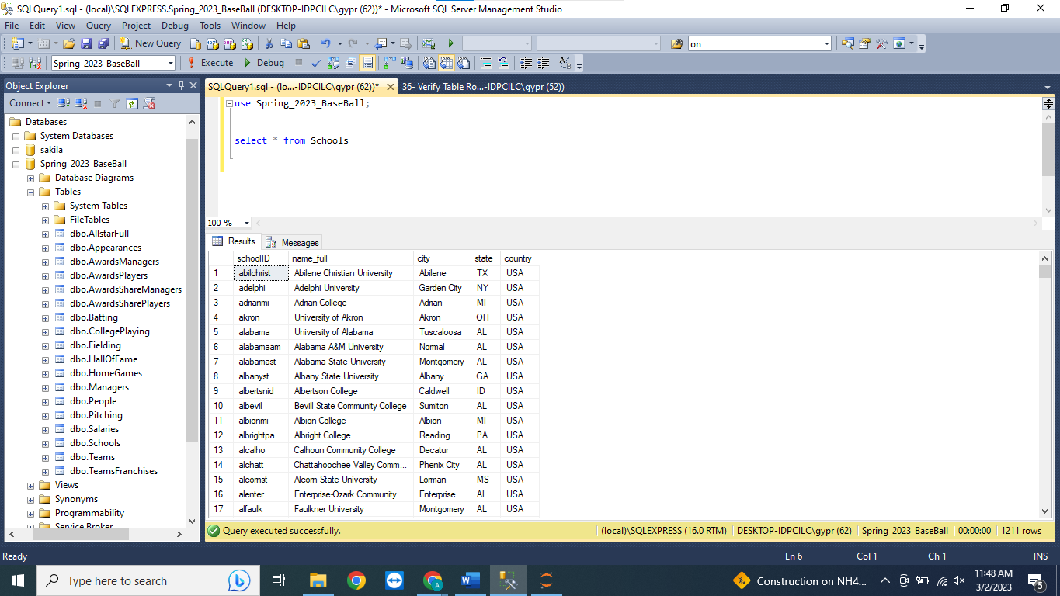

Step 2: To verify that every table is loaded correctly, script 20 showing the following results. We can verify the number of rows in each table.

